

Ankan Basu
Roll No.: 002310504015
MTCT 1st Year, 1st Semester
Programming Lab
Assignment - 8

Questions:
- 1.In a college with just one air conditioned room there are many requests to schedule activities in that room. Assume there are n requests numbered 1, 2, . . . , n. Each activity has a start times(i) and finish time f(i). At any point in time the room can be allocated only to one activity. So,if some set of activities have overlapping time intervals then only one of them can get that room. The problem is to find a subset of maximum size that has non-overlapping activities so that the maximum number of activities can use the room during the day. Output for a set of 11 activities and a subset of size 4 is shown below for reference that is the maximum sized subset of non-overlapping activities that can be scheduled.
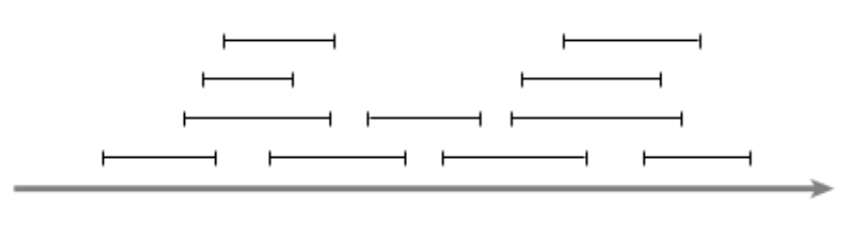

- The Edit Distance (or Levenshtein distance) is a metric for measuring the amount of difference between two strings. – The Edit Distance is defined as the minimum number of edits needed to transform one string into the other. The problem of finding an edit distance between two strings is as follows (i.e. the minimum distance to convert one string to another string): – Given an initial string s, and a target string t, what is the minimum number of changes that have to be applied to s to turn it into t ?

The list of valid changes are:
- Inserting a character
- Deleting a character
- Changing a character to another character (replace).

Examples:
- Input: str1 = “bmsse", str2 = “bmscse" Output: 1 We can convert str1 into str2 by inserting a ‘c'.
- Input: str1 = "cat", str2 = "cut" Output: 1 We can convert str1 into str2 by replacing 'a' with 'u'.
- Input: str1 = "sunday", str2 = "saturday" Output: 3 Last three and first characters are same. We basically need to convert "un" to "atur". This can be done using below three operations. Replace 'n' with 'r', insert t, insert a

Write a program in C that will take two strings as input and print the edit distance between those.

